Creating a react app

Download node.js (<https://nodejs.org/en/download/>)

Note: Node.js is a runtime environment for executing JavaScript code. It is not a programming language or a framework. It is a C++ program with the Chrome V8 JavaScript engine embedded in it which allows JavaScript to be executed outside of a browser.

Inside of vscode (<https://code.visualstudio.com/download>) create a new react.js app:

Open a new terminal and enter: npx create-react-app .

The root folder this app is being created in must not have uppercase letters or will throw an error.

The period after the command is needed to define that we want the created app to be located in the current directory

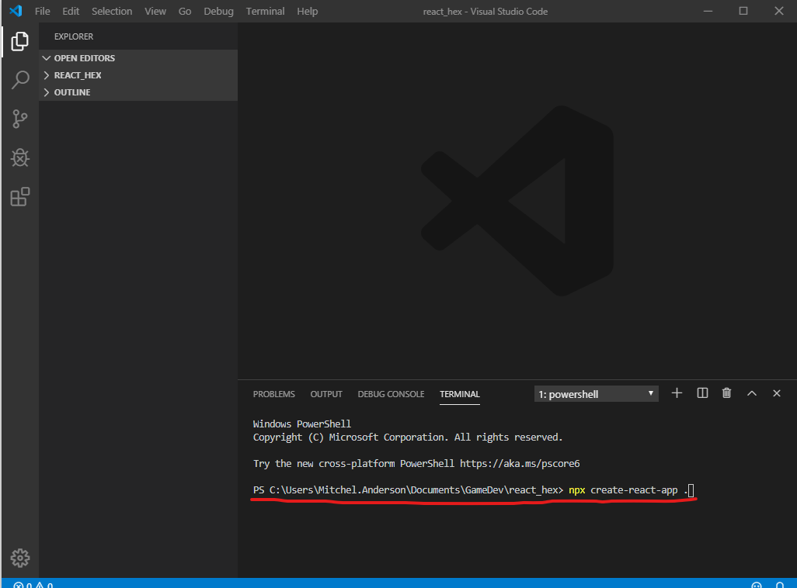

The index.html file has this in the body:

  <body>

    <noscript>You need to enable JavaScript to run this app.</noscript>

    <div id="root"></div>

  </body>

The entire react.js app sits inside of the div tag with id=”r

The index.js file gets the root element and renders the App.js:

ReactDOM.render(<App />, document.getElementById('root'));

The App.js file is where the div being rendered in index.js to the root div in index.html is found:

function App() {

  return (

    <div className="App">

      <header className="App-header">

        <img src={logo} className="App-logo" alt="logo" />

        <p>

          Edit <code>src/App.js</code> and save to reload.

        </p>

        <a

          className="App-link"

          href="https://reactjs.org"

          target="_blank"

          rel="noopener noreferrer"

        >

          Learn React

        </a>

      </header>

    </div>

  );

}

The App function returns JSX which looks like plain html but can have inline JavaScript. An example is the line holding the img tag with *src={logo}*. The logo variable comes from the imported value:

import logo from './logo.svg';

In the terminal use *npm start* to run the app